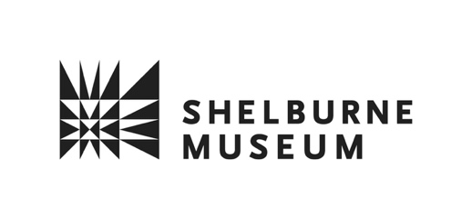

FOR IMMEDIATE RELEASE
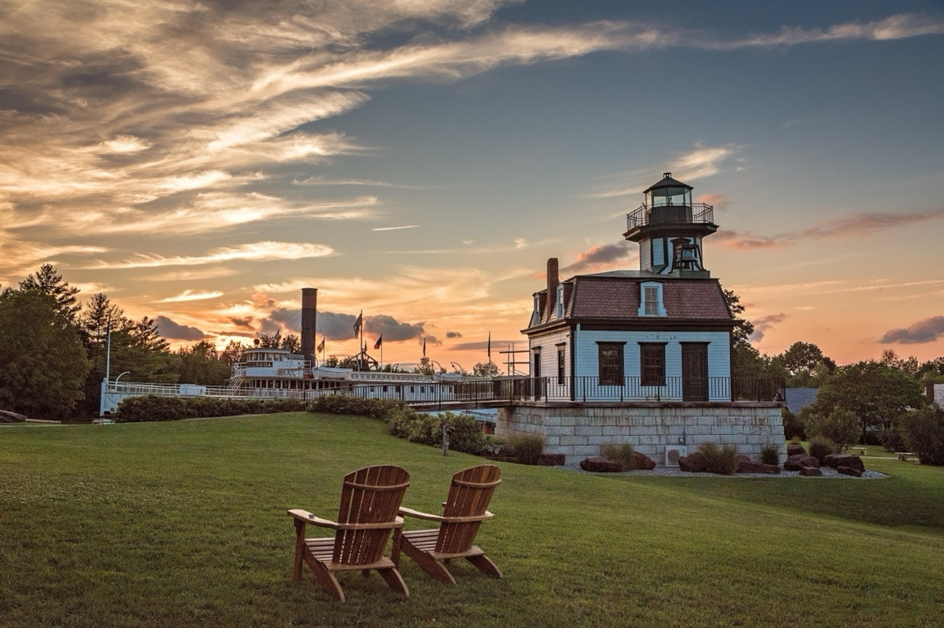
Shelburne Museum Kicks Off the Summer Season with Free Shelburne Summer Nights on Thursday, June 25

SHELBURNE, Vt. (June 5, 2026)—This summer, Shelburne Museum invites visitors to enjoy Shelburne Summer Nights, a free after-hours event series featuring live music, food trucks, gallery access, and family-friendly activities on select Thursday evenings. The events take place from 5:30 to 7:30 p.m. on June 25, July 23, and August 27, with free admission for all.
Set against the backdrop of Shelburne Museum’s 45-acre campus, Shelburne Summer Nights offers a unique opportunity to explore the museum after hours while enjoying performances by acclaimed regional musicians, local food vendors, and a relaxed summer atmosphere.
Musical performances include:
June 25 - The Tenderbellies
The Tenderbellies are a prominent, award-winning acoustic string band based in Burlington, Vermont. They are known for bridging traditional musical styles into a self-described "bluegrass(ish)" sound.
July 23 - Myra Flynn
Myra Flynn is an acclaimed American indie-soul singer/songwriter. Best known for her powerful vocals and emotionally honest lyrics, Flynn's musical repertoire seamlessly blends elements of soul, jazz, indie pop, and folk.
August 27 - Ray Vega Afro-Caribbean Jazz Ensemble
The Ray Vega Afro-Caribbean Jazz Ensemble is a musical group led by the internationally renowned jazz trumpeter, percussionist, and composer Ray Vega. The ensemble delivers a fiery, high-energy blend of traditional jazz concepts infused with rhythmic elements from Cuba, Puerto Rico, Jamaica, and across the Caribbean.
Shelburne Museum is open daily from 10 a.m. to 5 p.m. through October 25, 2026. For more information about Shelburne Summer Nights, visit shelburnemuseum.org
Shelburne Summer Nights are generously sponsored by an anonymous foundation, our Members, and donors to the Annual Fund.
Image credit: The steamboat Ticonderoga and the Lighthouse stand silhouetted against the evening sky at Shelburne Museum. Photo by Sarah McElvain Lavoie.
High-resolution image available HERE.
About Shelburne Museum
Founded in 1947 by trailblazing folk art collector Electra Havemeyer Webb (1888–1960), Shelburne Museum in Shelburne, Vermont, is the largest art and history museum in northern New England and Vermont’s foremost public resource for visual art and material culture. The Museum’s 45-acre campus is comprised of 39 buildings including the Pizzagalli Center for Art and Education and Webb Gallery featuring important American paintings by Andrew Wyeth, Winslow Homer, Anna Mary Robertson “Grandma” Moses, John Singleton Copley and many more. Construction is underway for the Perry Center for Native American Art, designed in partnership with Indigenous voices and devoted to the stewardship and exhibition of the Native American art in the museum’s care, scheduled to open in 2027. For more information, please visit shelburnemuseum.org.
For media inquiries, please contact:
Leslie Wright
Director of Marketing and Communications
Shelburne Museum
lwright@shelburnemuseum.org
802-985-0880
Kristen Levesque
Kristen Levesque Public Relations
kristen@kristenlevesquepr.com
207-329-3090
###

